|  |
| --- |
| [Type the company name] |
| KITCHEN WRATH |
| HIGH CONCEPT DOCUMENT |
|  |
| **Rui Quan** |
| **5/30/2014** |

|  |
| --- |
| This document depicts the high concept of the game idea, Kitchen Wrath |

**TABLE OF CONTENTS**

1. **HIGH CONCEPT**
2. **FEATURES**
3. **PLAYER MOTIVATION**
4. **GENRE**
5. **TARGET CUSTOMER**
6. **COMPETITION**
7. **UNIQUE SELLING POINTS**
8. **TARGET HARDWARE**
9. **DESIGN GOALS**
10. **CHARACTERS**

**HIGH CONCEPT**

Bukiyo (a Japanese word for “Clumsy”) is the head chef of a famous restaurant in Tokyo. Thanks to his father’s efforts, it brought him the inheritance to own his father’s beloved restaurant. On the first day of his job, he came unprepared to serve an endless queue of customers waiting to eat the prestigious food they would expect. Little they know, they were heading into genocide.

**FEATURES**

* 2D side-scrolling, hack and slash game.
* Cool power ups.
* Particle system
* Physics applications(Food)
* Recipe Based System

**GAMEPLAY**

Each game session will be limited to an estimated 30 seconds to a minute or so.

The goal of the game is to survive and complete as many recipes as possible before the time runs out

The Player will be on the left side of the screen with the camera tracking the player and moving around with him. The player will constantly run and slowly increase speed as time goes by. The game ends if the player fails to jump over to the next platform or when the player fails to jump over the barricades or the time limit expires.

**MODES**

Normal Mode : The game is restricted to timings each session before ending the session

Endless Mode : The game is not restricted to any time limit and continues on until the player dies

**INPUT**

Touch Screen

Left half will be used for jumping

Right half will be used for attacking

**PLAYER MOTIVATION**

Enable Players to enjoy the thrill when they are meeting objectives, avoiding hindrances and all at the same time having sarcastic content be included in the gameplay. To enjoy a funny, chaotic yet potentially hard-core gameplay experience.

**GENRE**

2D side-scrolling platformer, hack and slash game.

**TARGET CUSTOMER**

Teenagers and Young Adults. (Age 13-21 and above)

Casual & Hardcore

**COMPETITION**

Jetpack Joyride

**UNIQUE SELLING POINTS**

* Recipe based game
* Discover new recipes and fulfil them

**TARGET HARDWARE**

* Android devices, possibly iOS devices

**DESIGN GOALS**

* **Simple:** Very simple 2D side-scrolling game where player play as Bukiyo to run and slash ingredients through the world
* **Spam:** Slash ingredients and discover recipes to feed your hungry customers and obtain highscores
* **Funny:** ­You may get your employees killed if you slash the wrong “ingredients” in the kitchen. Cops will pursue you in the kitchen if you cut the chefs

**CHARACTERS**

* Humble Chef, who cooks fervently despite the dangers of the chopping blade Bukiyo holds.
* Cops, people who wears a dark blue uniform chasing after you (Bukiyo) if you kill off too many of your Chef.
* Hungry Customers, waiting on the counter to eat up the delicious food the restaurant has to offer.

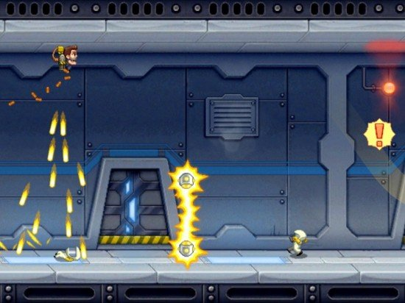

**Artstyle:**

Cartoon + Pixel art (Reference from Jetpack Joyride)

I am proposing 2D because within 2 months it will be a good time to produce many art content using pixel/cartoon art.